**Perimedr, Arwynebedd a Chyfaint**

CBAC Haf 2008 Mathemateg Ychwanegol Papur 1

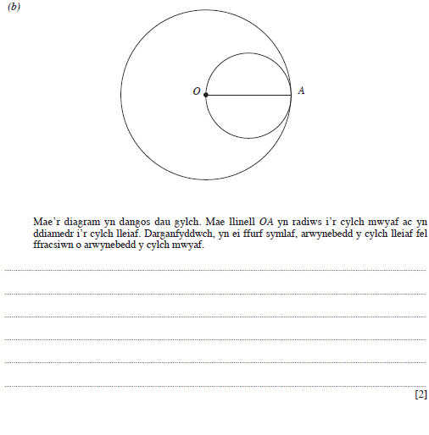

CBAC Haf 2008 Mathemateg Ychwanegol Papur 1

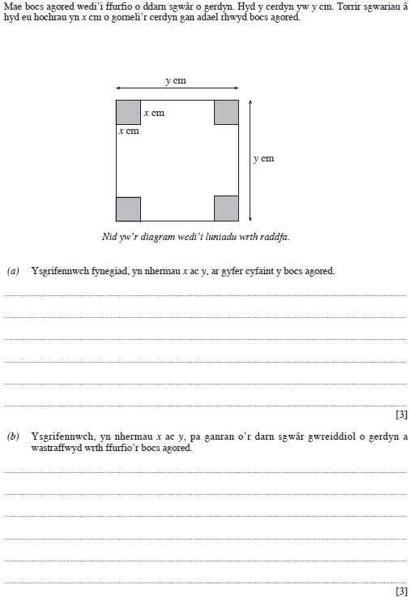

CBAC Haf 2008 Mathemateg Ychwanegol Papur 1

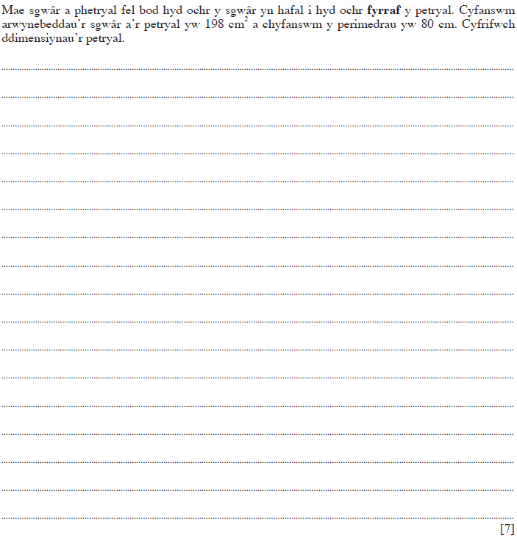

CBAC Haf 2008 Mathemateg Ychwanegol Papur 1

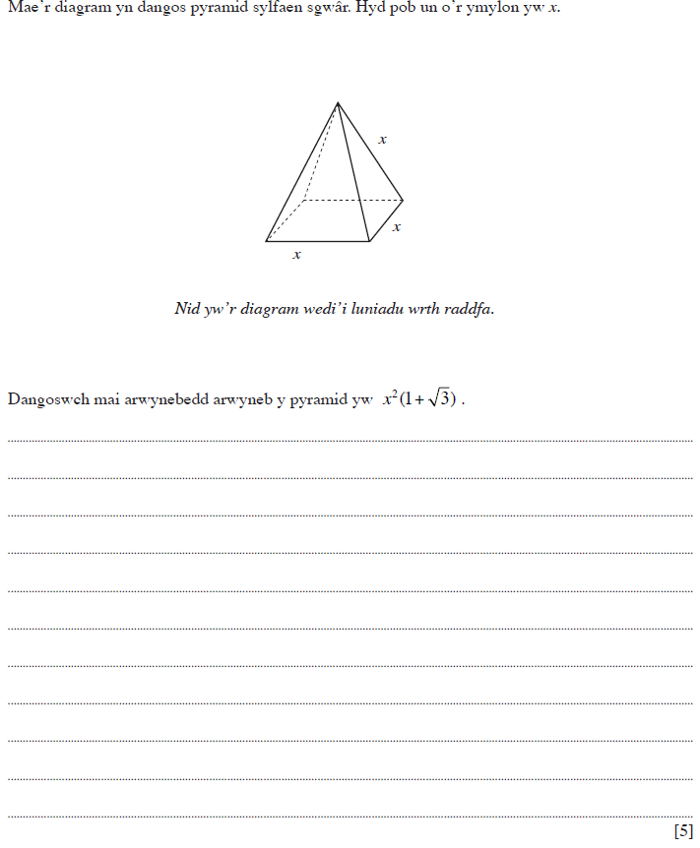

CBAC Haf 2009 Mathemateg Ychwanegol Papur 2

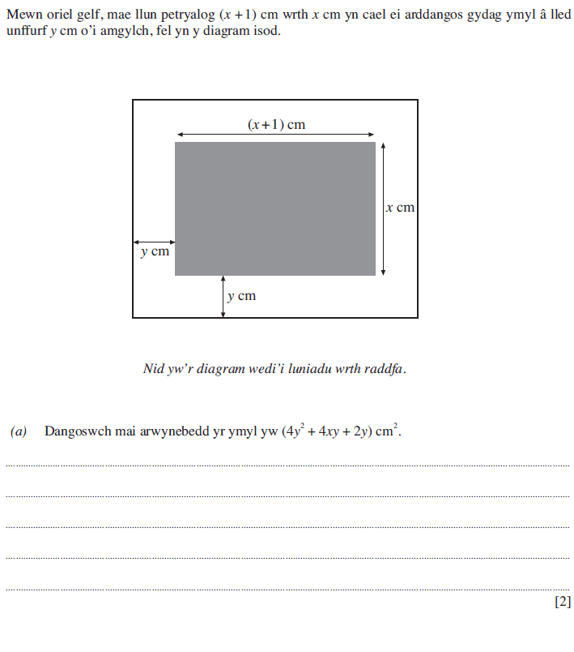

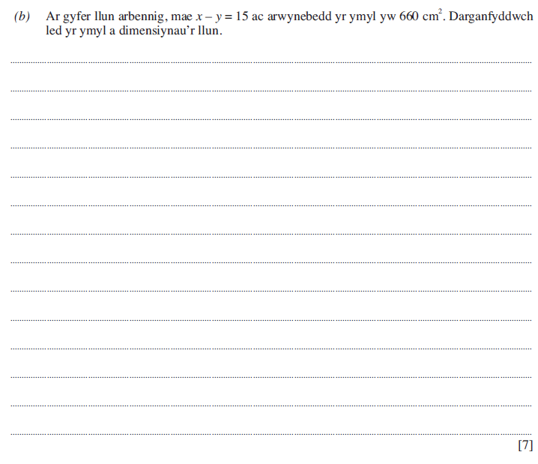

CBAC Haf 2009 Mathemateg Ychwanegol Papur 2

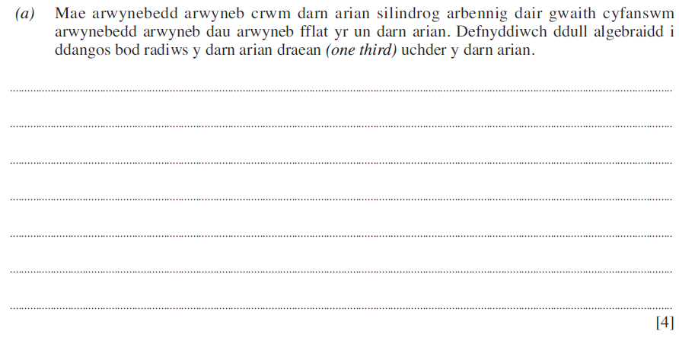

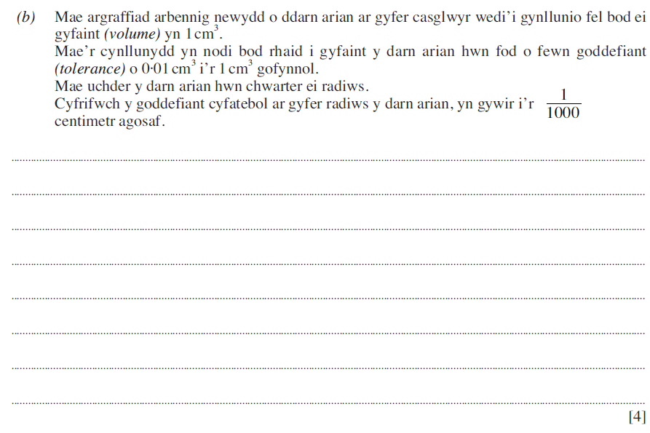

CBAC Haf 2009 MathemategYchwanegol Papur 2

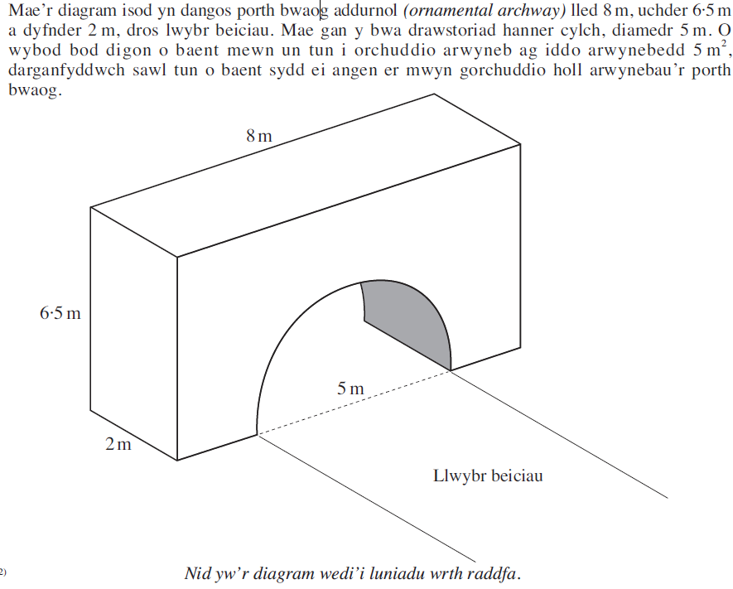



CBAC Haf 2010 Mathemateg Ychwanegol Papur 2

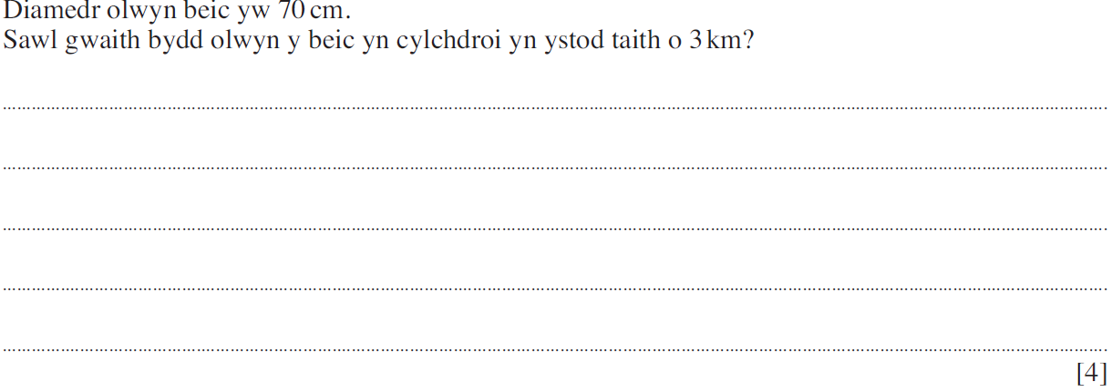

CBAC Haf 2010 Mathemateg Ychwanegol Papur 2

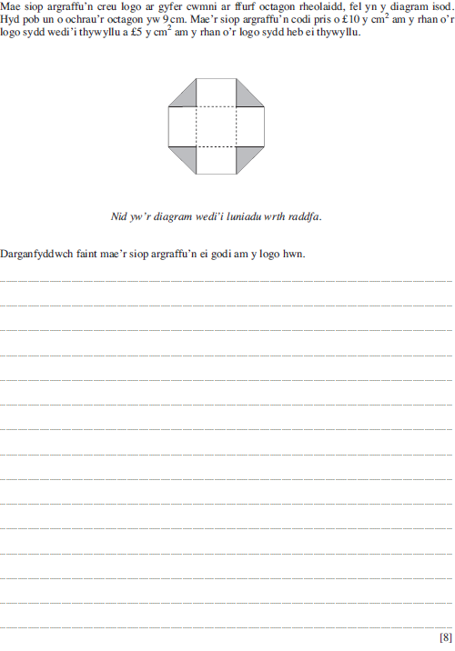

CBAC Haf 2010 Mathemateg Ychwanegol Papur 2

